## EDA report on Domestic Average Price(Monthly)

The given dataset provided the domestic average price per litre in Naira for each month from January 1985 to April 2024.

Data information:

**Rows**: 472

**Columns**: 2

1. Month_Year
2. Price in Naira per litre

### **Fuel prices monthly**

**Correlation:**

1. There is a strong correlation of fuel prices compared to previous month. Each month the fuel price is slightly higher than the previous month.
2. We see that fuel prices are mostly between 100 and 200.

**Trend:**

1. The trend of fuel prices is upwards.
2. However, we see a sharp increase in price after 2020. This could be due to Covid effect and following that global economic condition.

#### **Detailed Report is given below**

#### **Distribution of fuel prices:**

Plotted histogram chart to find the distribution of fuel prices. This gave us an idea of how much the prices are distributed.

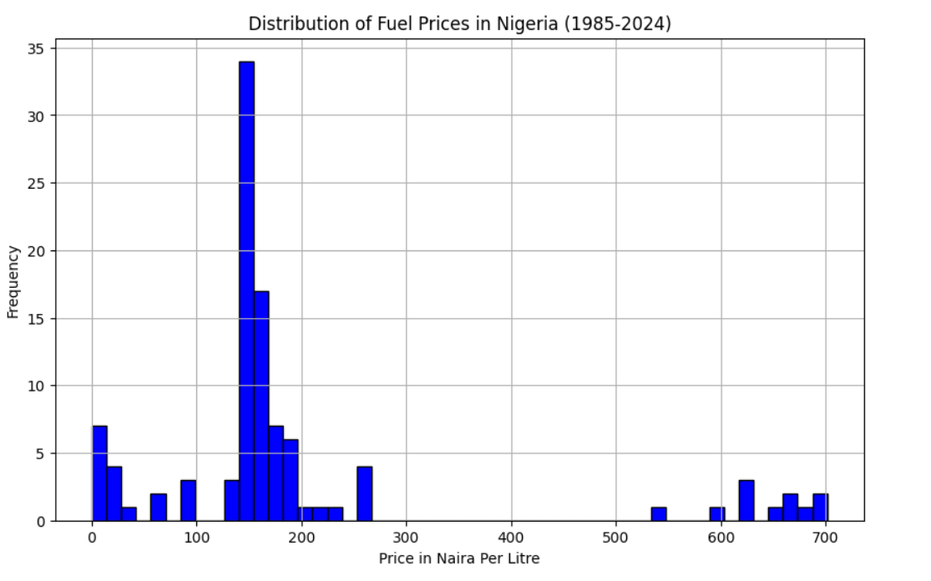

##### Observation:

1. The distribution is right-skewed,
2. This suggests that while lower prices are more common, there are occasional periods with very high fuel prices. This suggests that while lower prices are more common, there are occasional periods with very high fuel prices.
3. The highest frequency is seen around the 200 Naira per litre range.
4. There are notable gaps between clusters of prices, suggesting periods of stability followed by significant price jumps.

#### **2. Box plot on fuel prices:**

Created box plot on fuel prices to confirm the fuel price frequency.

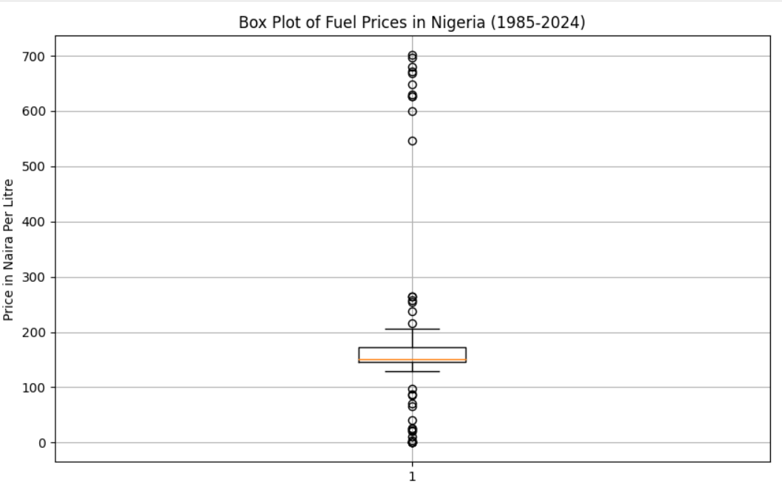

From the histogram chart and box plot, we infer that the **Price Concentration:** Majority of prices are between 100 and 200 Naira.

#### **3. Time series of Fuel prices:**

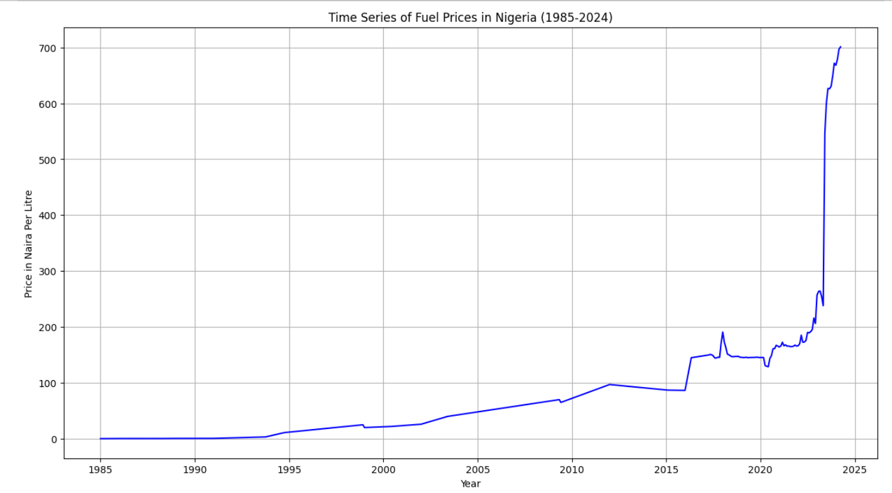

##### Observation:

1. From the Linear plot, we observe that the fuel prices started rising exponentially post Covid i.e. from 2020.
2. The fuel prices rose drastically from 2022.

#### 4. **Seasonal decomposition of Monthly fuel prices:**

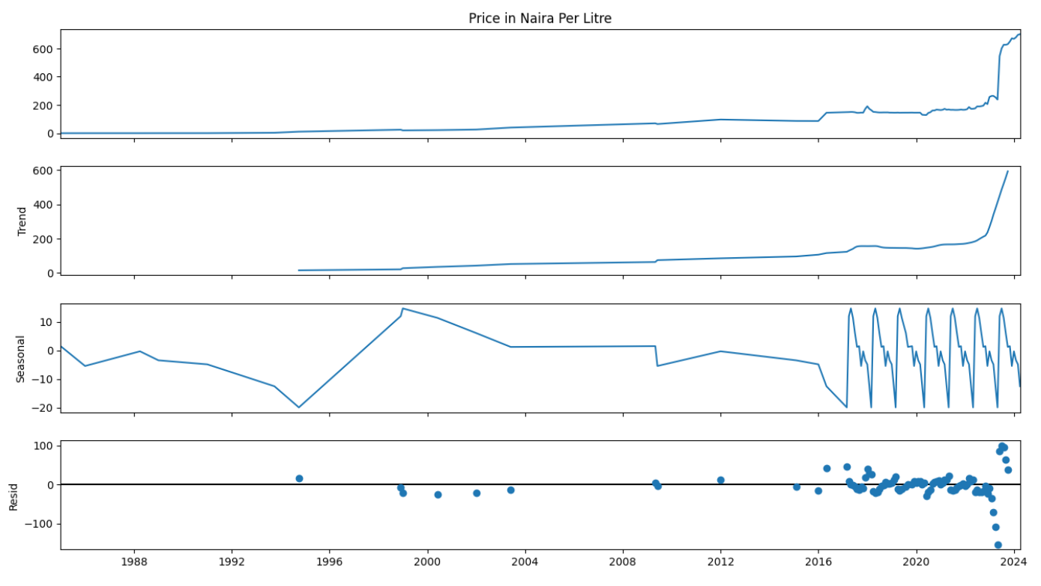

1. The trend component shows a clear and steady increase in fuel prices, highlighting a long-term upward movement.

2. Seasonal Patterns: The seasonal component reveals regular fluctuations.

#### **5. ADF:**

The ADF test is used to determine whether a given time series is stationary or not. Stationarity is a crucial property in time series analysis and forecasting, as most statistical models assume that the time series data is stationary.

**ADF Statistic:** 1.0735255844022455

**p-value:** 0.9949842186876896

High p-value (0.995) is high: This is much higher than 0.05, indicating that the test in the time series is not stationary. This means the data has patterns that change over time, such as trends (upward or downward movement) or seasonal effects (regular cycles).

#### **6. Autocorrelation**

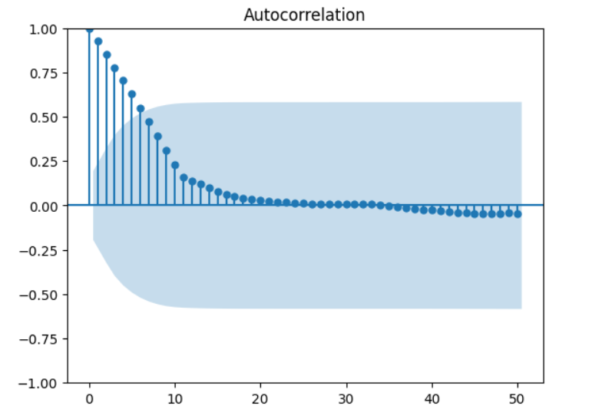

1. The first few lags show a high positive correlation.

2. The correlation decreases as the lag increases.

Finding the autocorrelation with lag= 1

**Autocorrelation with lag 1:** 0.9809237300512768

1. The autocorrelation value of 0.98 indicates that the price of fuel in one month is almost the same as its price in the previous month.
2. This strong similarity shows that the prices are very closely linked from one month to the next.
3. it is a clear sign that . Specifically, it supports the observation that fuel prices have been steadily increasing over time. This helps us understand that the rising prices are not just random fluctuations, but part of a consistent upward trend.

#### **7. Lag plot**

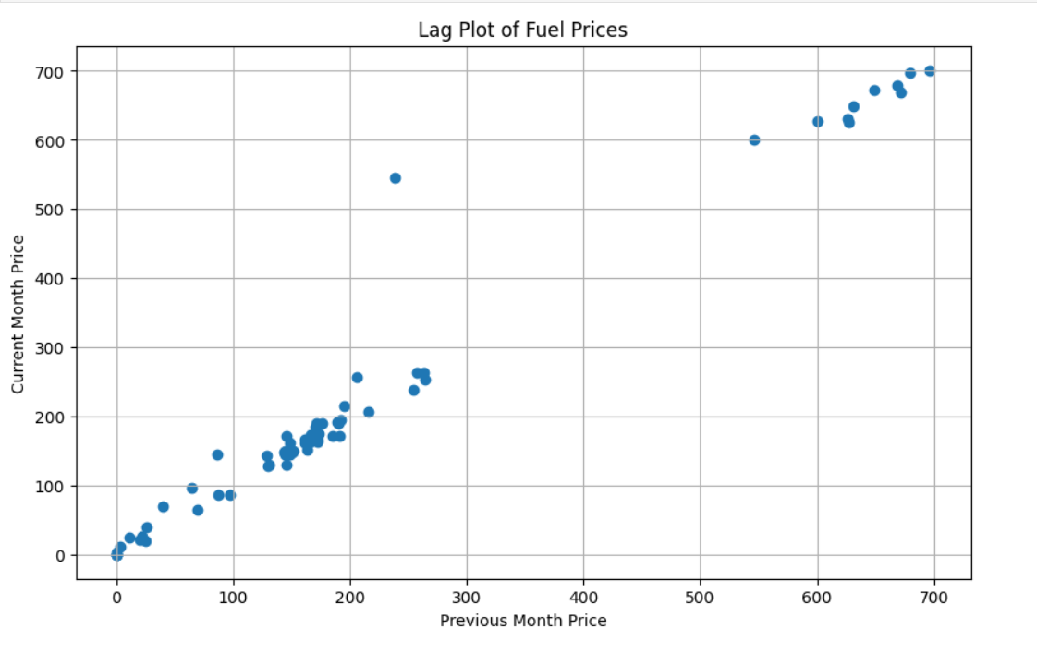

1. The points lie close to a straight line, indicating a strong linear relationship between the current and previous month's fuel prices.
2. This may suggest that the fuel price in one month is strongly dependent on the price in the previous month.